Change default floor flow

User flow diagram - workplace

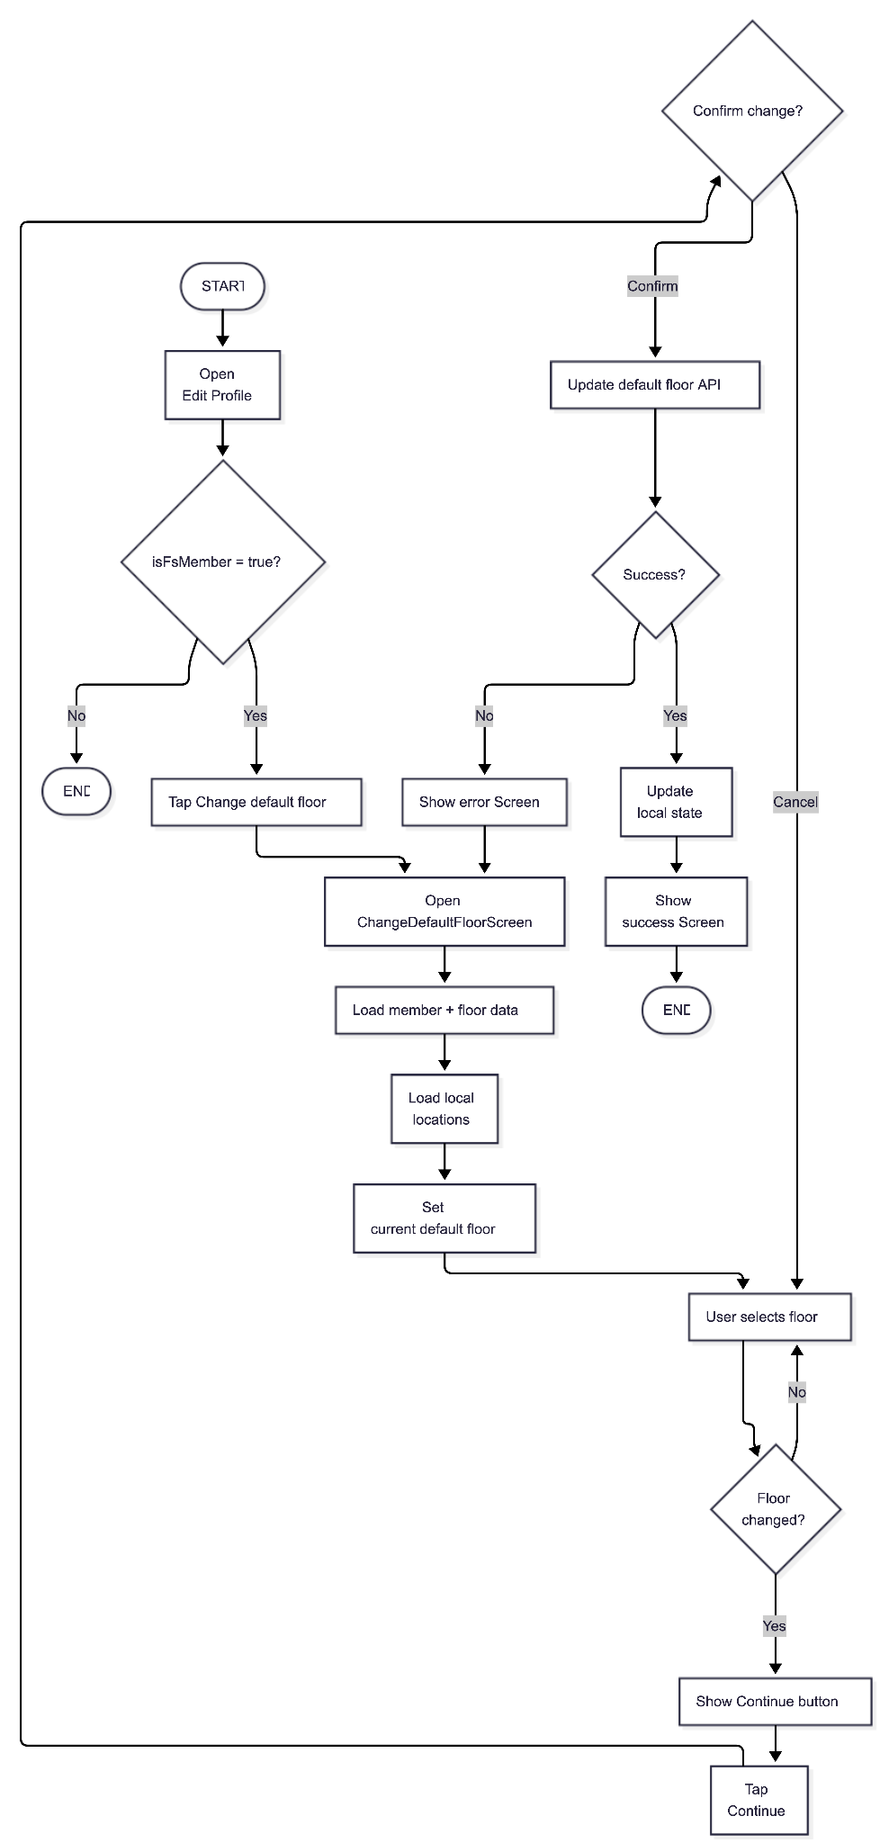

User flow diagram - residence

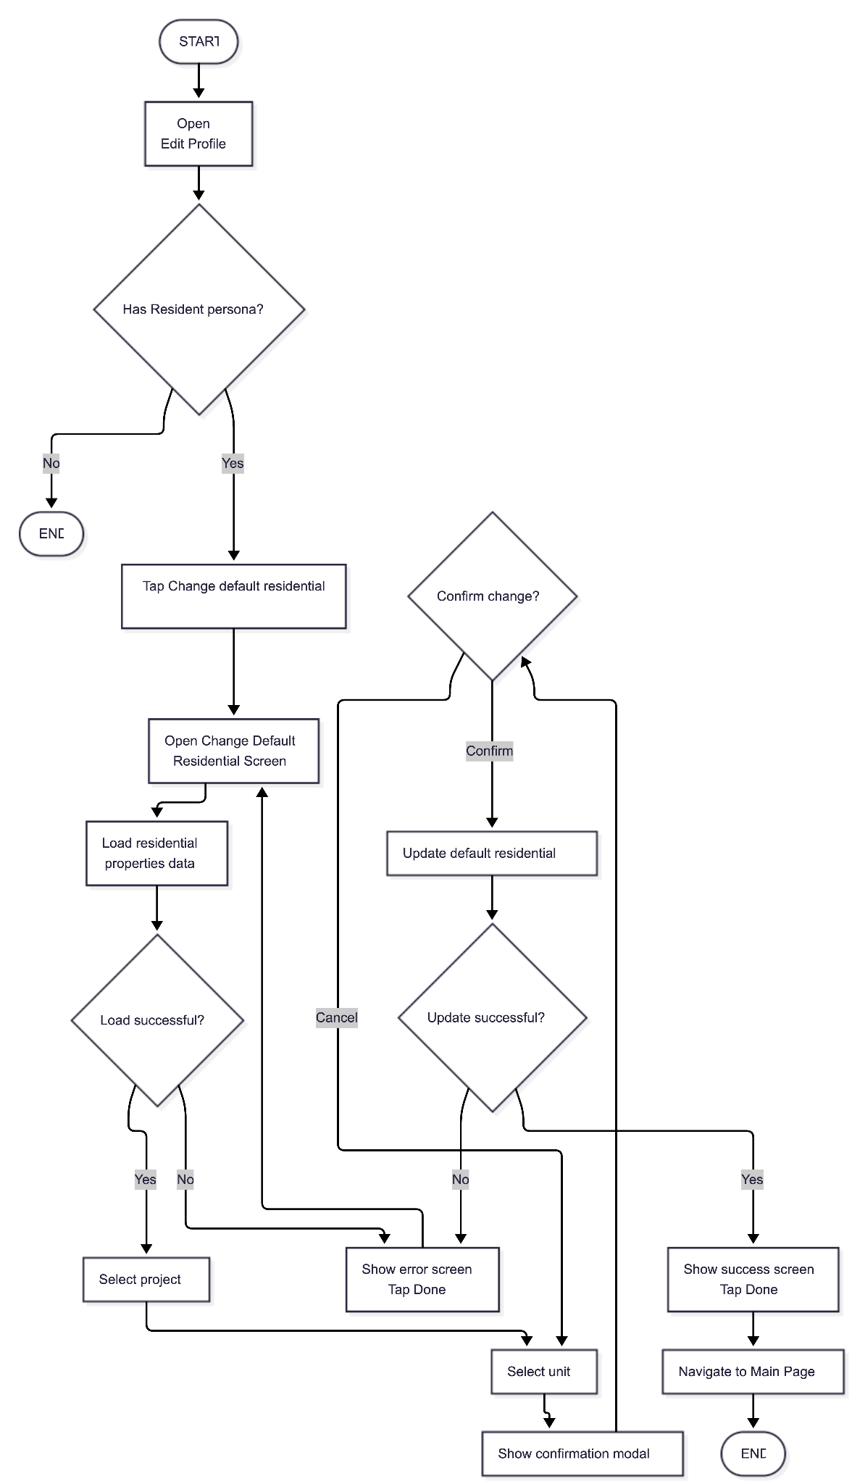

Sequence diagram - workplace

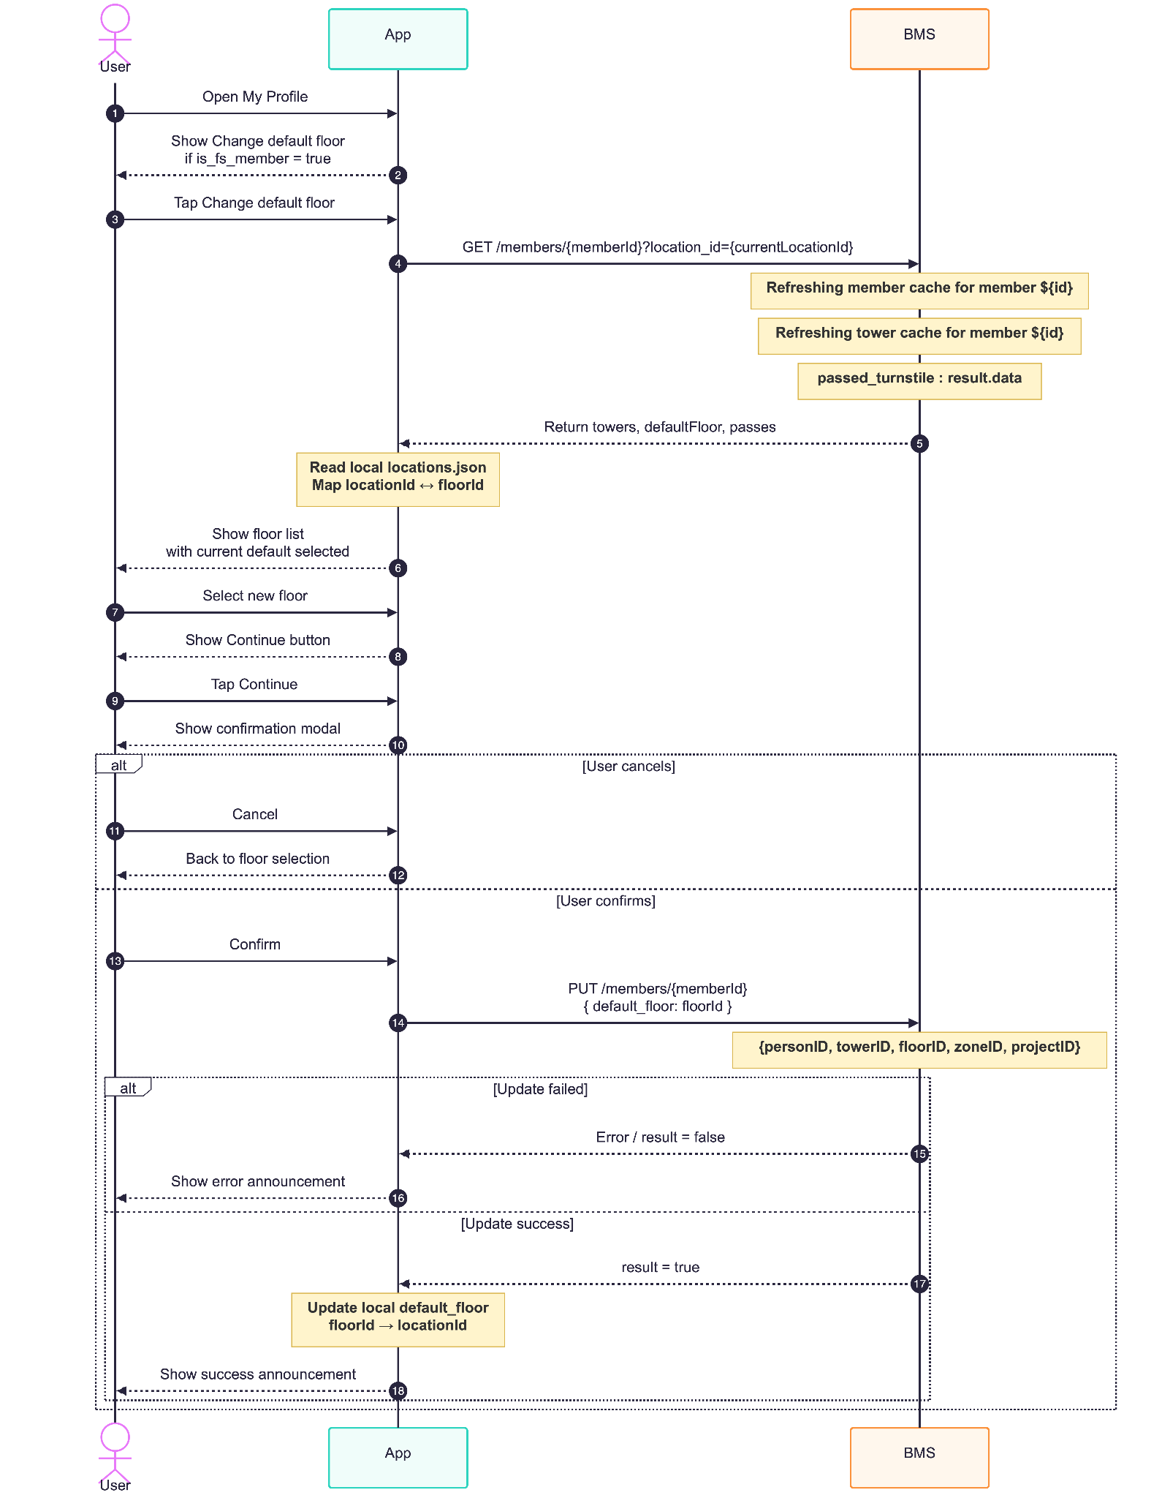

Sequence diagram - residence
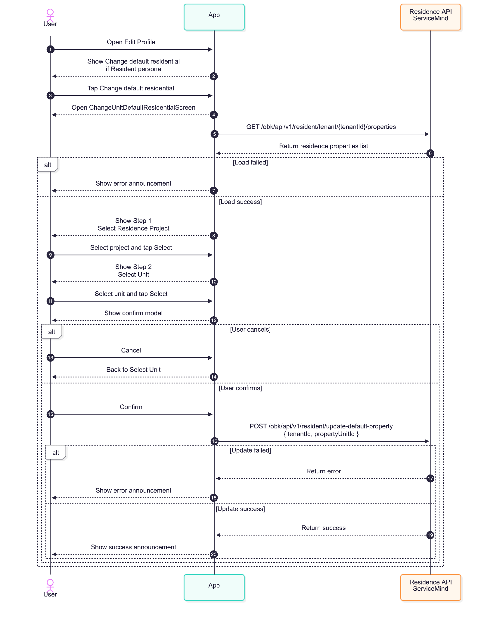

API Description - Workplace (BMS Service)

5.1 Get member workplace

Endpoint GET /members/{memberId}?location_id={locationId}

Description
Retrieves the workplace structure (towers and floors) for a specific member, scoped by location_id. Also returns the member’s current default floor.

Example request / response

Request Structure

Path Parameters
Name | Type | Required | Description
memberId | string | Yes | Unique identifier of the member

Query Parameters
Name | Type | Required | Description
location_id | string | Yes | Location identifier to scope workplace data

Headers
Name | Type | Required | Description
Authorization | string | Yes | Bearer token for authentication

Example request

GET /members/{memberId}?location_id={locationId}
Authorization: Bearer <token>

Example Response

{
"data": {
"defaultFloor": "FLOOR_9",
"towers": [
{
"id": "T1",
"name": "Tower A",
"floors": [
{ "id": "FLOOR_8", "name": "Floor 8" },
{ "id": "FLOOR_9", "name": "Floor 9" }
]
}
]
}
}

Related Cache Key
- member_data_${memberId}_${location_id}
- member_tower_${memberId}_${location_id}_${authorizedLocation}_${authorizedFloor}_${member.updated_at}

5.2 Update Member Default Floor

Endpoint PUT /members/{memberId}

Description
Update the member’s default floor.

Request Structure

Headers
Header | Type | Required | Description
Authorization | string | Yes | For authorization API

Body

Body | Type | Required | Description
default_floor | string | Yes | New floor id to set as default

Example request / response

Example request

PUT /members/12345
Authorization: Bearer <token>
Content-Type: application/json
Body: { "default_floor": "FLOOR_8" }

Example response

{
"data": {
"result": true
}
}

Related Cache Key
- MEMBER_CACHE_KEY_identifier_${identifier}
- MEMBER_CACHE_KEY_accountId_${member.account_id}
- MEMBER_CACHE_KEY_uid_${member.uid}

5.3 Error Scenarios (All Workplace Endpoints)

Scenario | Status Code | Description
Unauthorized | 401 | Missing or invalid token
Forbidden | 403 | No permission for member/location
Member not found | 404 | Invalid memberId
Validation error (query) | 400 / 422 | Invalid or missing location_id
Validation error (body) | 400 / 422 | Invalid default_floor
Logical failure | 200 | Business rule failure
Server error | 500 | Unexpected failure

API Description - Residence (ServiceMind Service)

6.1 Get Tenant Properties

Endpoint GET obk/api/v1/resident/tenant/{tenantId}/properties

Description
Retrieves the list of residence properties for a tenant.

Request Structure - ServiceMind

Path Parameters
Name | Type | Required | Description
tenantId | number | Yes | Tenant identifier

Headers
Name | Type | Required | Description
Authorization | string | Yes | Bearer token
lang | string | Yes | Language code (e.g. en, th)

Example Request

GET obk/api/v1/resident/tenant/{tenantId}/properties
Authorization: Bearer <token>
lang: en

Example Response

{
"properties": [
{
"projectId": "proj_001",
"propertyUnitId": "pu_67890",
"houseNumber": "A-101",
"isDefault": true,
"projectsName": "Condo A",
"projectsNameThai": "คอนโด เอ"
}
]
}
}

Error Scenarios
Scenario | Status Code | Description
Unauthorized | 401 | Invalid client credentials
Not Found | 404 | User not found
Error | 5xx | Service Error

6.2 Update Default Residence

Endpoint POST /obk/api/v1/resident/update-default-property

Description
Updates the tenant’s default residence/unit.

Request Structure

Body Parameters
Name | Type | Required | Description
tenantId | string | Yes | Tenant identifier
propertyUnitId | string | Yes | Selected unit ID

Headers
Name | Type | Required | Description
Authorization | string | Yes | Bearer token
lang | string | Yes | Language code (e.g. en, th)
Content-Type | string | Yes | application/json

Example Request

POST /obk/api/v1/resident/update-default-property
Authorization: Bearer <token>
Content-Type: application/json
lang: en
Body:
{
"tenantId": "12345",
"propertyUnitId": "pu_67890"
}

Example Response

{
"success": true
}

Error Scenarios
Scenario | Status Code | Description
Validation error | 400 | Invalid payload
Authentication failed | 401 | Unauthorized
Resource not found | 404 | tenantId or propertyUnitId does not exist
Upstream/service failure | 5xx | Service Error

